Приложение

Join the Kazan 2019 Youth Entrepreneurship Forum!
The next Kazan OIC Youth Entrepreneurship Forum will take place in Kazan from 20 – 26 April, 2019.
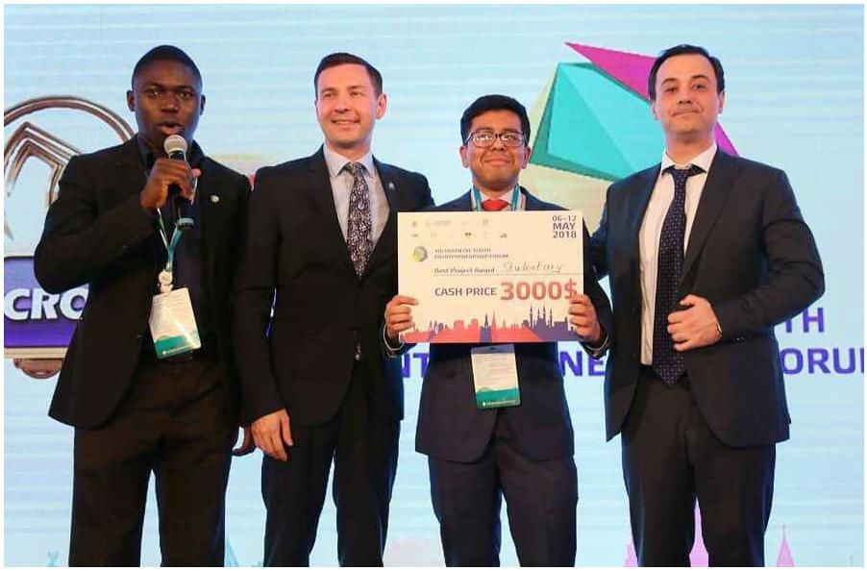
You are the founder of an early-stage startup with a focus on the OIC geography? You want to learn how to achieve product/market fit and raise pre-seed or seed investment?
Fill in the application form before 28 February 2019 !
Kazan OIC Forum, what is it?
The Kazan OIC Youth Entrepreneurship Forum is a joint initiative of the Organization for Islamic Cooperation (OIC) and the government of the Republic of Tatarstan. Each year we invite 30 startups from around the world to join our eight-week acceleration program online and attend our bootcamp in Kazan. Some of our notable guests were Natalya Kasperskaya (Co-founder of Kaspersky), Rustam Minnikhanov (President of Tatarstan), Dr. Yousef A. Al-Othaimeen (Secretary-general of the OIC), and Haluk Bayraktar (General Manager at Baykar, Turkey).
The Forum covers accommodation and feeding for all startups. We also offer up to 50% (or $500) in air ticket fees for select startups.
Apply Now!
Investment
While the Forum does not, at this stage, directly invest in startups, we facilititate the process of fundraising. We work with partner venture firms; some of which are listed below: AdamTech Ventures (Jordan); Limitless Ventures (India); KamaFlow (Russia); Tatarstan Venture Company (Russia); Turkey Technology Team Foundation (Turkey); IT Park (Russia); Syed Shazad (Angel, UK); Haluk Bayraktar (Angel, Turkey). Over $2 million have been raised through the forum and its network over the years.

The Program
The strength of our program comes from the diversity in expertise of our partners. Prior to the event in Kazan, startups are enrolled in our eight-week acceleration program online where various speakers from the industry discuss the fundamentals of starting up: from ideation, to product development, to sales, all the way to fundraising. In Kazan, our program offers a bootcamp of lectures, workshops and one-on-one conversations between startup founders and mentors. Go to www.kazanoicstartups.org to see some of our rockstar experts and read about some of our alumni!
At its core, the bootcamp is a community of collaboration. As much as you will learn from our world-class speakers and experts, you will also learn more from each other. Fostering this community is what creates the magic.
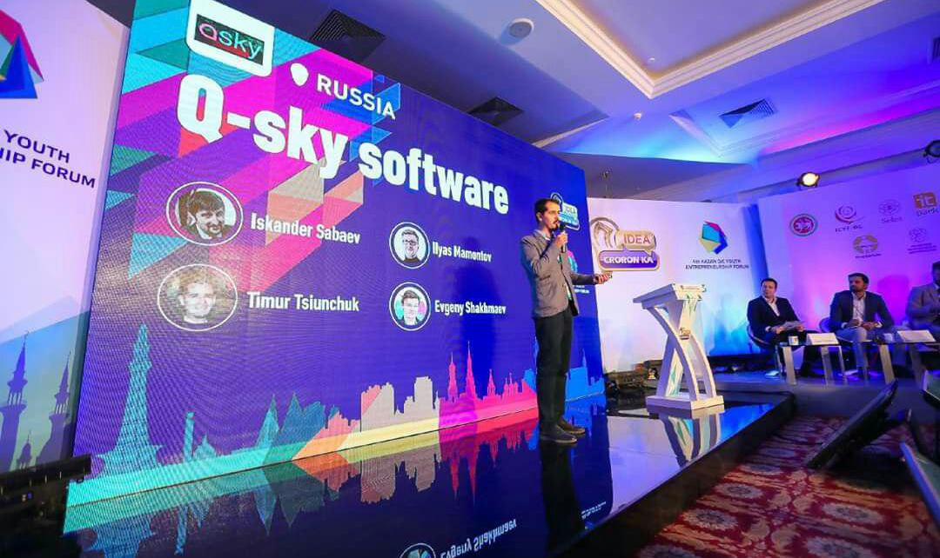
The bootcamp ends with Demo-Day: an open event for investors as well as the general public. During Demo Day, startups are each given 3 minutes to pitch their products to investors and the top three teams voted by our panel of experts win a cash prize of up to $10,000. Some startups receive funding on Demo Day while others land contracts to follow up with, however with our program, our aim is not only to help founders fundraise but also to create a space where founders can learn, make professional connections, and meet future collaborators.
Useful information
The Forum takes place on 20-26 April, 2019 in Kazan, Russia.
- Transport, accommodation and food costs of participants are covered by the organizers (Maximum 2 participants per project).
- Please note that selected participants are asked to book their transport tickets themselves. The organization will then refund travel expenses up to 500 USD per project, according to the original receipts and tickets sent by the participants.
- English is the official language.

Come and join us for an unforgettable experience!

